**Project Design Phase-II**

**Technology Stack (Architecture & Stack)**

|  |  |
| --- | --- |
| Date | 27 June 2025 |
| Team ID | LTVIP2025TMID52085 |
| Project Name | ResolveNow: your platform for online complaints |
| Maximum Marks | 4 Marks |

**Technical Architecture:**

**The Resolve Now platform is designed with a scalable 3-tier architecture that includes the presentation layer (frontend), business logic (backend), and data storage layer. The solution ensures performance, security, and ease of integration with third-party APIs (e.g., Stripe for payments).**

**Example:** ResolveNow: your platform for online complaints



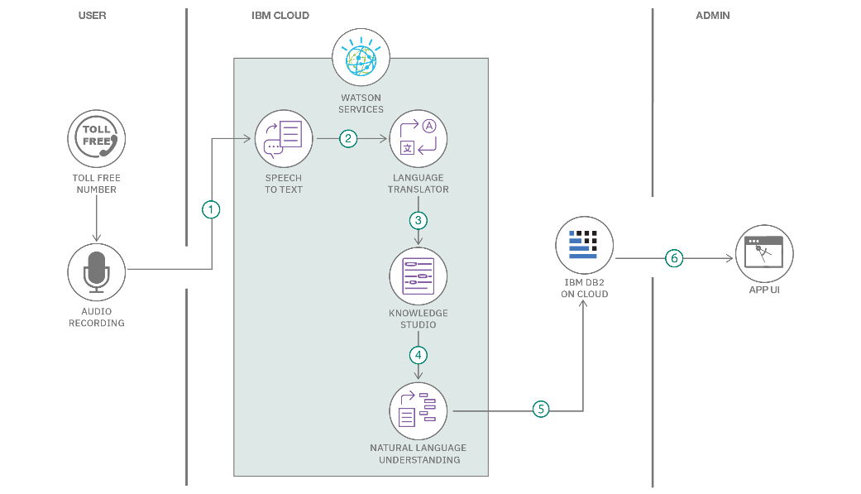

**Table-1 : Components & Technologies:**

|  |  |  |  |
| --- | --- | --- | --- |
| **S.No** | **Component** | **Description** | **Technology** |
|  | User Interface | Web-based interface for clients and freelancers | HTML, CSS, JavaScript / React Js etc. |
|  | Application Logic-1 | Complaints posting | Node.js, Express.js |
|  | Application Logic-2 | Admin panel | React js, Node js |
|  | Database | Stores user data, jobs, applications, messages | MongoDB |

**Table-2: Application Characteristics:**

| **S.No** | **Characteristics** | **Description** | **Technology** |
| --- | --- | --- | --- |
|  | Open-Source Frameworks | Frontend frameworks | React.js, Node.js, BootStrap, Tailwind CSS |
|  | Scalable Architecture | 3-tier architecture with RESTful APIs | Microservices |

**References:**

[**https://c4model.com/**](https://c4model.com/)

[**https://developer.ibm.com/patterns/online-order-processing-system-during-pandemic/**](https://developer.ibm.com/patterns/online-order-processing-system-during-pandemic/)

[**https://www.ibm.com/cloud/architecture**](https://www.ibm.com/cloud/architecture)

[**https://aws.amazon.com/architecture**](https://aws.amazon.com/architecture)

[**https://medium.com/the-internal-startup/how-to-draw-useful-technical-architecture-diagrams-2d20c9fda90d**](https://medium.com/the-internal-startup/how-to-draw-useful-technical-architecture-diagrams-2d20c9fda90d)